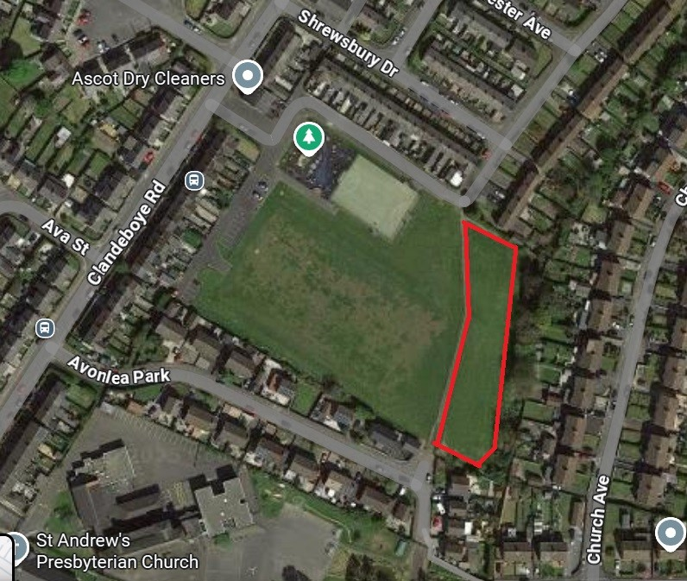
Clandeboye Pitch and Park

