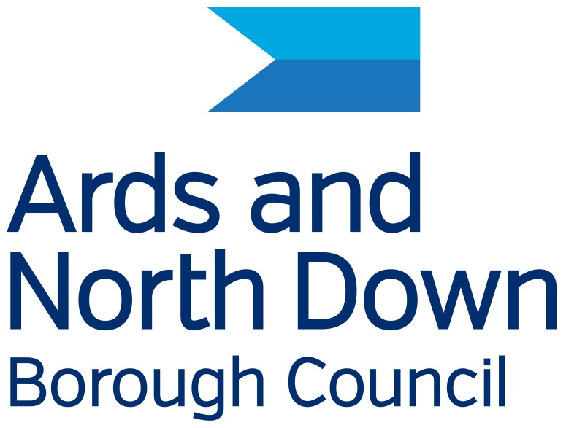

Ards and North Down Borough Council

Disability Action Plan

2025 – 2029

Purpose of the Disability Action Plan

The Action Plan is important because of a law called Section 75, Northern Ireland Act 1998 and Section 49A, Disability Discrimination Act 1995 (as amended) This Disability Action Plan is our promise to help make sure everyone can use our services. This plan has been created to support seven goals in the Corporate Plan of Ards and North Down Borough Council.
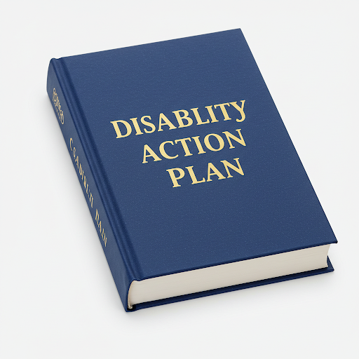

We want everyone to feel good about people with disabilities. We will help people get involved and remove barriers that make life difficult. Our services, information, and locations will be easy and fair for everyone.
The Council does many things to help people in our area.
- They keep areas clean and nice
- They help people in our community
- They maintain public spaces like parks and leisure centres
- They bring visitors to our area
- They speak for people who live here
- They decide how to spend money.

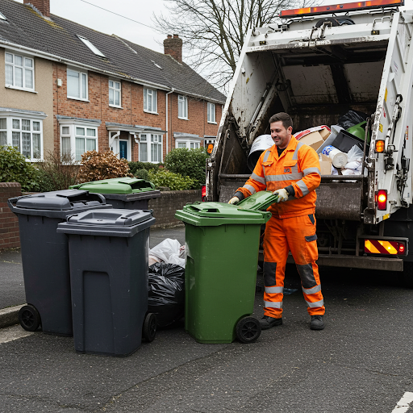

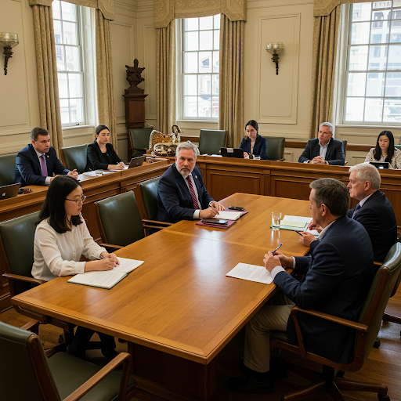
Elected Members:
40 people are chosen by you to represent you on the Council.
They decide how Council money and property is used and how to make our area better.
One Elected member is known as the Mayor, they represent our area.


About 1,000 people work for the Council all with different jobs.
The Chief Executive is the person in charge.
The Leadership Team manage departments, making sure that everything works and making plans.


The Mayor and the Chief Executive want the Equality plan to work well.
They will use all the things the Council has to help like money, people and time.

Getting Information in a Way That's Easy for you
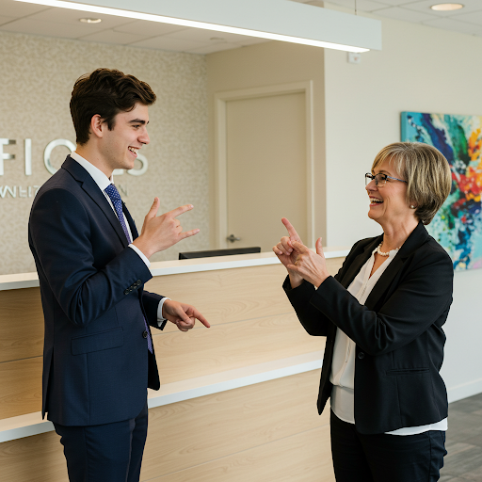
The Council wants to make sure everyone can understand important information. So, they can give you:
- Big letters: If you find small print hard to read.
- Easy words: If you need things explained simply.
- Someone to read it to you: If you want to listen to the information.
- Translated into other languages: If English isn't your first language.
- Use sign language
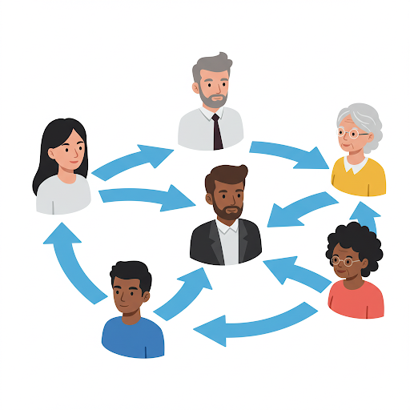
Working Together
We want everyone in our area to be able to tell us what they think. We want to know how we can make our services and plans better.

Sharing the Plan


We will put the plan on our website and social media. If you need extra help to understand, contact the Compliance Officer (Equality and Disability), Telephone: 0300 0133333 or email equality@disability@ardsandnorthdown.gov.uk
Ards and North Down Draft Disability Action Plan 2025 - 2029
This is our plan for 4 years.

Big Goal 1. Help us decide What services we give. What plans we make. Where we spend money.


Making sure disabilities are on everyone’s mind
We will check all our rules to make sure they are fair for everyone and help people with disabilities.
We make sure the rules follow the law about helping people with disabilities.

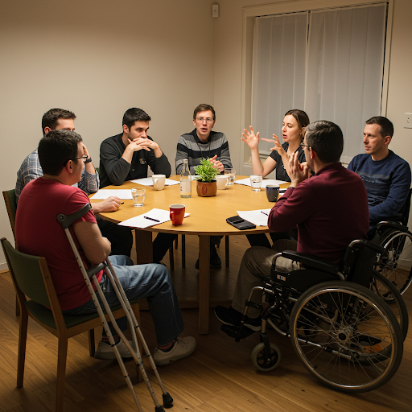
Talking Together About Disability
We have a group called the Disability Forum, where people with disabilities and their helpers meet with the Council, anyone can join. They tell us what they need. We work together to make things better.

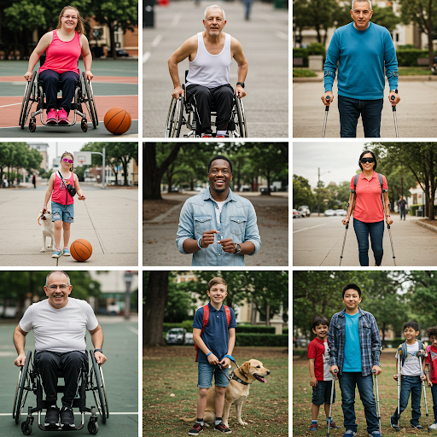
Working together to celebrate disabilities
We want to work together with disability groups to help people learn more and find information and support. We will celebrate disability by sharing and promoting important days and events related to disability.


Giving information in ways you can understand
We want to make sure everyone can get information from the Council in the language and format they need. We will use Sign Video more in Council buildings and have more translation services.

Getting you involved
We want to help people with disabilities get involved with the Council.
Our staff will know how to include and connect with disabled people when using our services

Big Goal 2. Making our area's money strong
We want to help our area's money grow so everyone can have a good life.

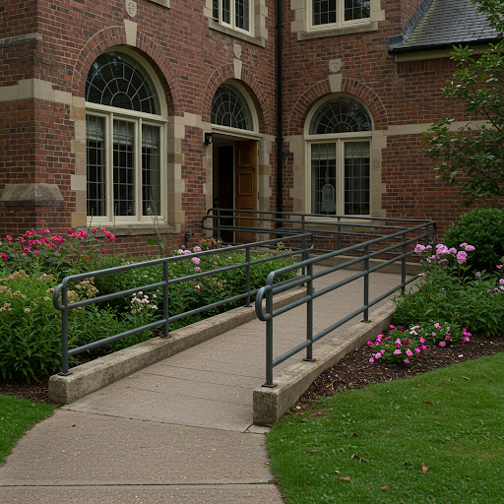
Make Jobs for everyone
We want to make getting a job with the council fair and open to everyone.
We will make more necessary adjustments during council interv Interviews and in council services
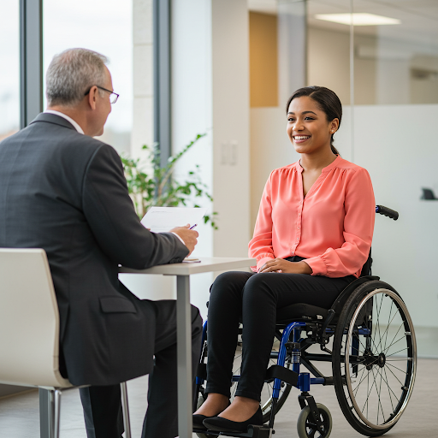
Getting the right people for our jobs
We will communicate and support jobs for certain groups by introducing ringfencing

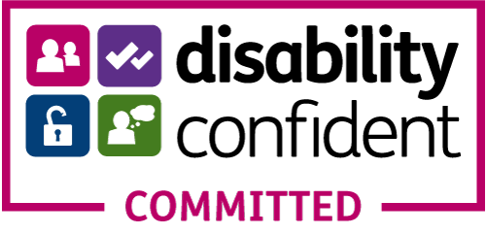
Keep up our Disability Confident Status
We want to guarantee the Council remains a Disability Confident Committed employer (Level 1)

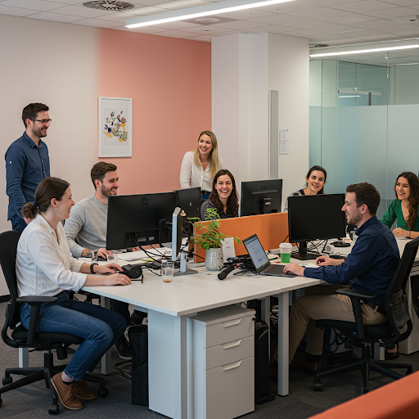

Helping staff with disabilities
We will make sure all staff know what help they can get. We will ask staff if they have a disability and if they want to tell us.
Big Goal 3. Making our area a fun and happy place
We want to make our area a place where everyone feels welcome and happy.

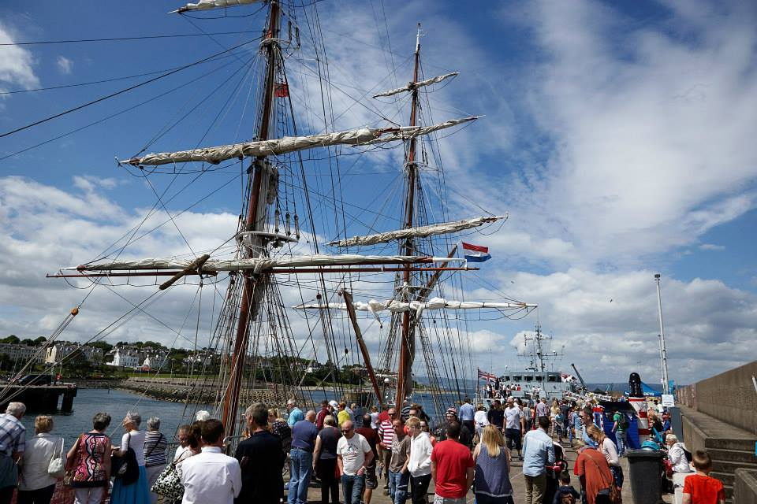

Making events Accessible
We want all public events to be easy for everyone to attend. We will make changes to help people with disabilities join large events.

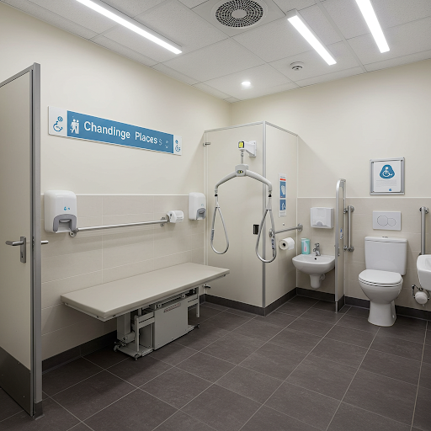

Bringing changing places to our events
We want people and their carers to join in any large events by having the right toilets available.

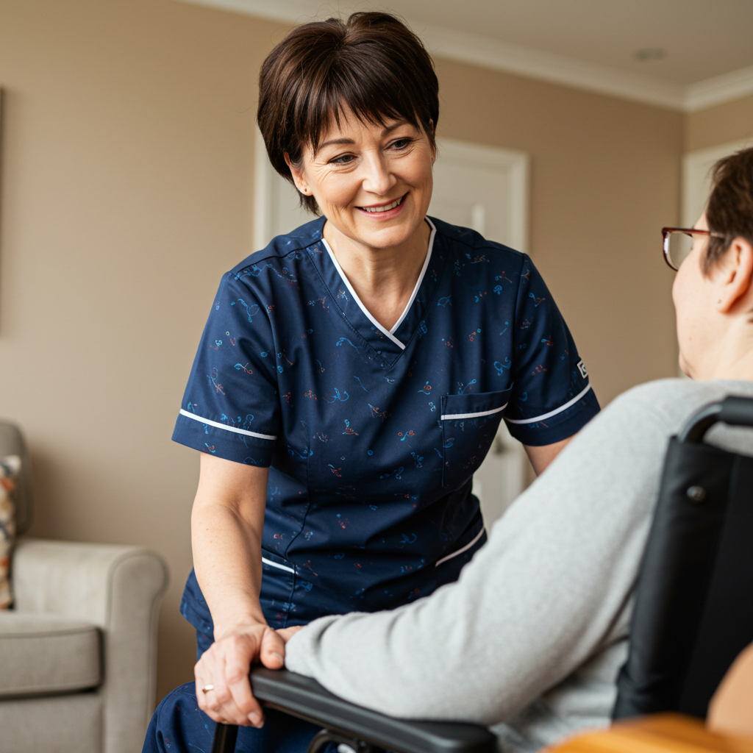

Host a carers event.
We know that carers are very important. So, we want to host a special event just for them every year.

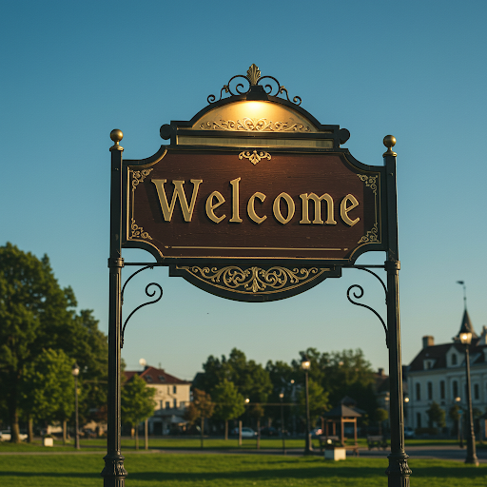
Work with other public services
There are somethings that the Council can’t do, so we want to work with community partners and service providers that can help us. We will have a Borough with services that are welcoming and are disability friendly.

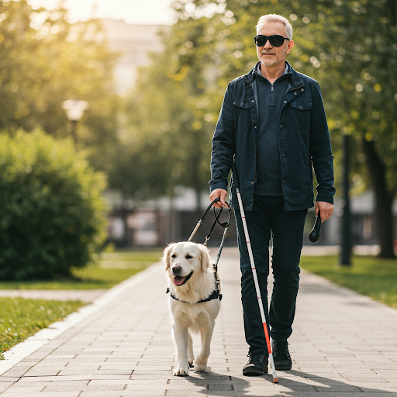
Become a visually aware Borough
We want to make Ards and North Down a better place for everyone, especially those blind and partially sighted people.

Big Goal 4. Making our communities safe and friendly

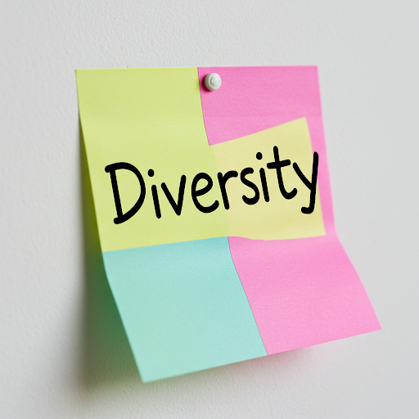

Celebrating our diverse Borough
3 of the Elected members will make sure diversity is included in Council business.

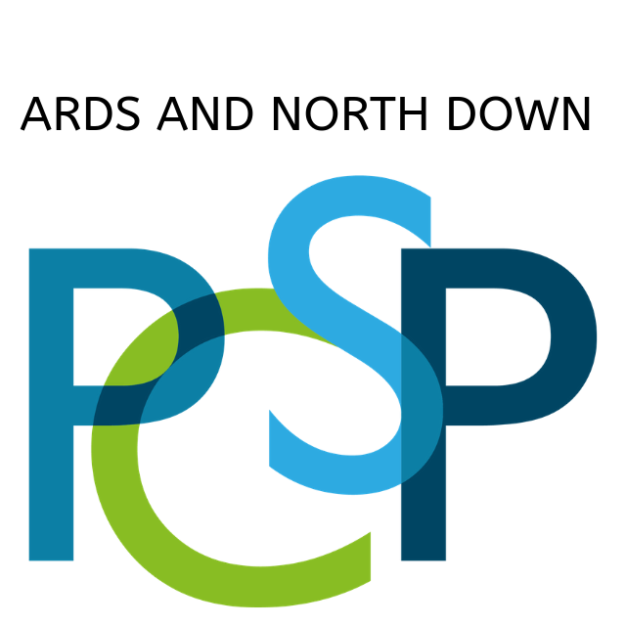

Council departments talking to people with a disability.

The Ards and North Down Policing and Community Safety Partnership (PCSP) will hold meetings that include people with disabilities. These meetings will ensure that people with disabilities can express their views on safety in their communities.

Provide Accessible Information

We want all our information to be accessible to everyone, we will ensure that our website is fully adapted for people with disabilities and make sure we provide information in other ways.

Big Goal 5. Helping people be active and healthy

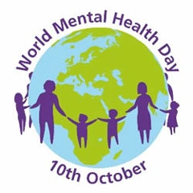
Host an event for World Mental Health Day
We want more people to know about mental health. We will share information in Council information.
More people will understand mental health and where to get information and help.
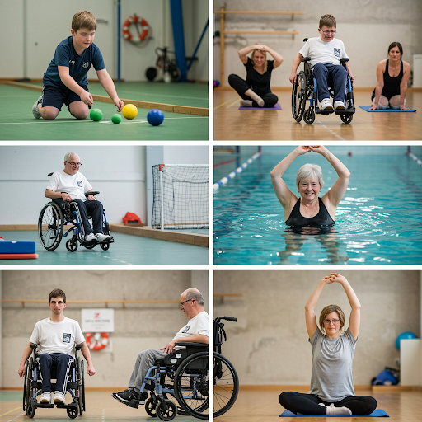

Making Leisure activities open to everyone
We want to take away things that stop people from joining in leisure activities. We want everyone to have fun and meaningful experiences.

Using AssessAble to show our facilities.

AccessAble give information on disability access in all our buildings. We want to grow this service and make sure the information is correct and up to date.
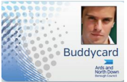
Raise awareness of our Buddy Card Scheme
We want more people using our Buddy Card Scheme.
Everyone who needs a carer with them to help will have a Buddy Card. This means your carer can get in free, but can’t take part in activities.
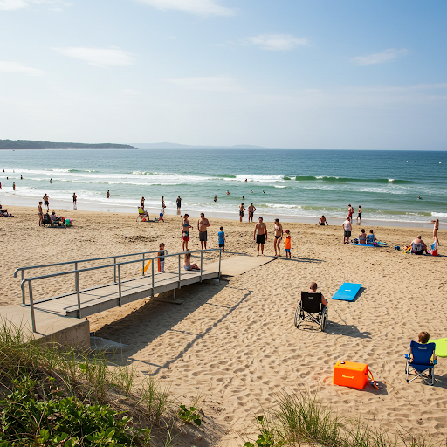
Making Groomsport Beach easy to use
We want to make sure the beach and toilets at Groomsport are easy for everyone to use.
So families and groups can have fun together on the beach.
To have a Dementia Friendly Garden
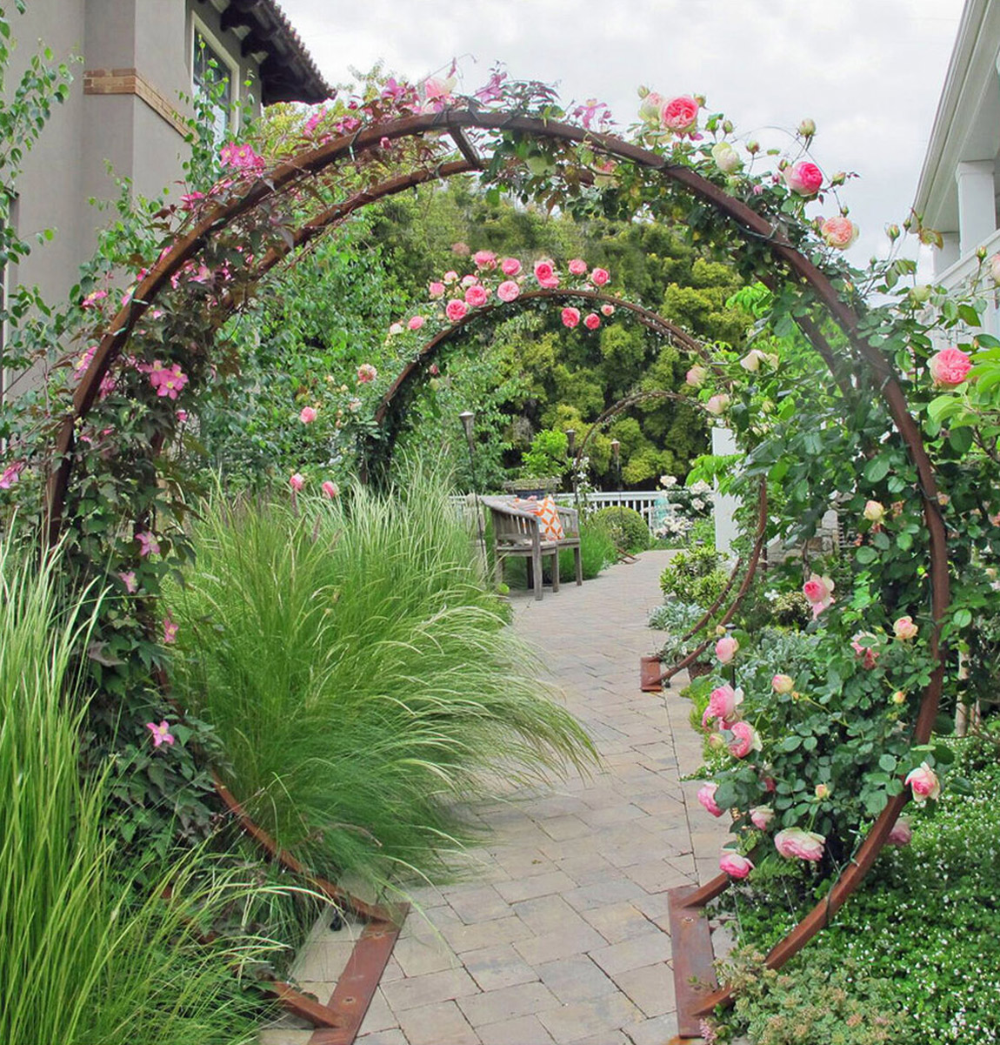
To make an outdoor space that is safe, fun, and easy to use for people with dementia. The garden will be full of sensory planting for people affected by dementia.

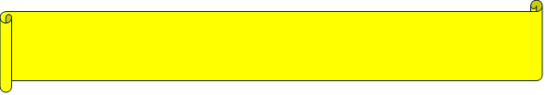
Big Goal 6. Having a Council that works for you
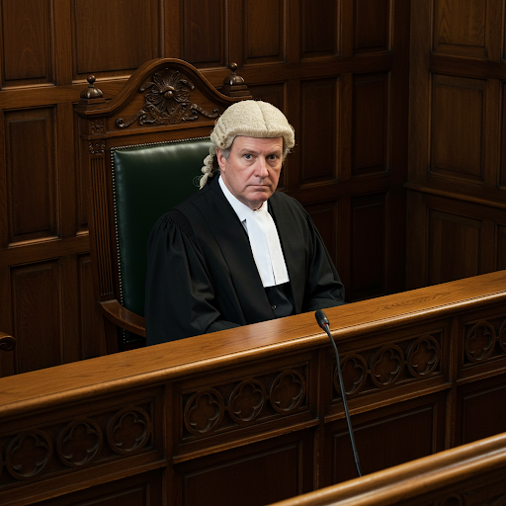
Make sure everyone in charge knows about the rules (laws)
Make sure everyone who works for the Council know what they need to do for Disability laws.
We will give them information to help them understand the rules. So everyone will feel included.

Big Goal 6. Having a Council that works for you.

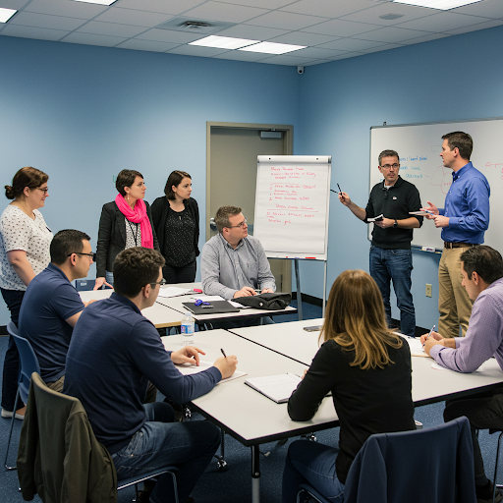
Train our Staff
We want to make sure everyone who works for the Council know how to treat people with a disability.
All our staff will be happy and confident to work with people with different disabilities.

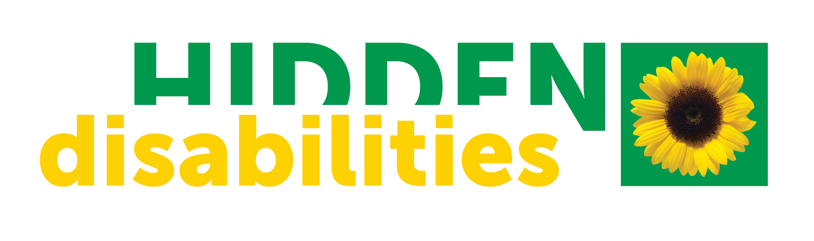
Raise awareness of hidden disabilities
We want everyone to know about hidden Disabilities.
Our staff will know how to help and support people with disabilities you can't see.

Help and support our staff
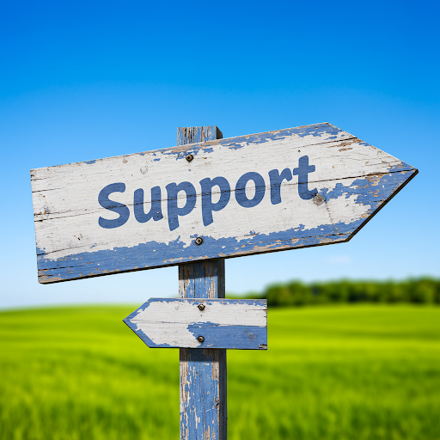

We want to take steps to keep our staff healthy and looked after. We will have happy staff that feel supported.

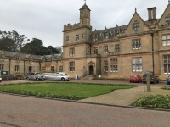

Promote equality of opportunity in our services.
We want every customer to have a great experience.
If you need help or changes to use our services, just ask. We will do our best to help.

We need you to tell us what you think of our plan.
You can answer these questions on a computer
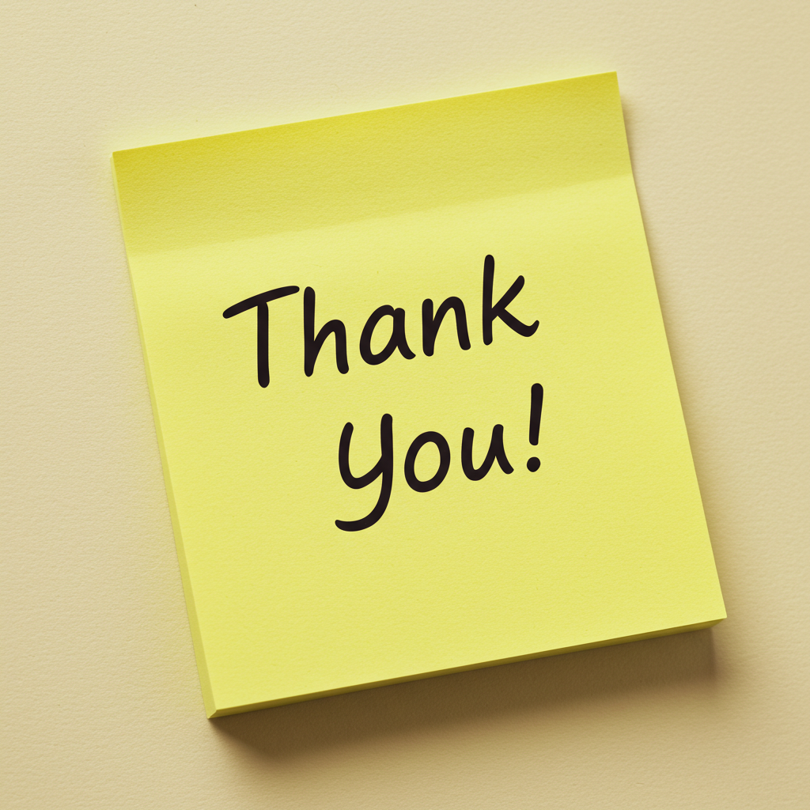
or smart phone.
Scan this code with your smart phone

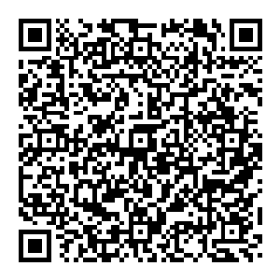

If you want to talk to us, you can phone us too. Call and ask for the Equality Officer 0300 013 3333 or email equalityanddisability@Ardsandnorthdown.gov.uk
Thank you

