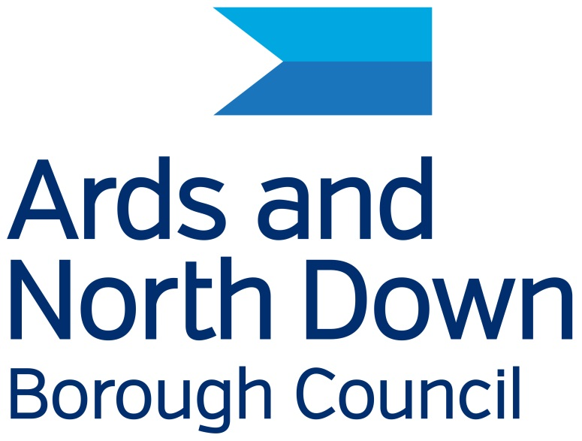

Ards and North Down Borough Council

Equality Action Plan

2025 - 2029

Purpose of the Equality Action Plan
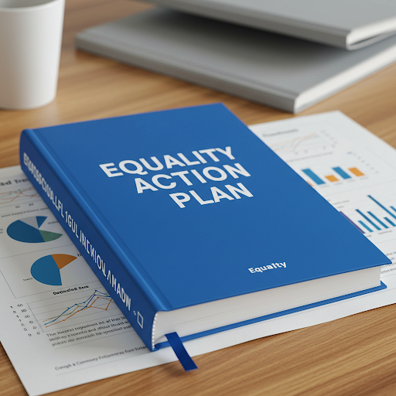
The Equality Action Plan is important because of a law called Section 75 of the Northern Ireland Act 1998.
This means we have to treat everyone fairly, regardless of their religion, political views, skin colour, age, marital status, sexual orientation, disability, or family responsibilities.

We have to check if our services are fair. Sometimes, we find things that aren't fair.
We make plans to fix these things.
We want to improve things for everyone, and make sure our services are fair and easy to use.
The Council does many things to help people in our area.
They keep areas clean and nice
They help people in our community
They maintain public spaces like parks and leisure centres
They bring visitors to our area
They speak for people who live here
They decide how to spend money.

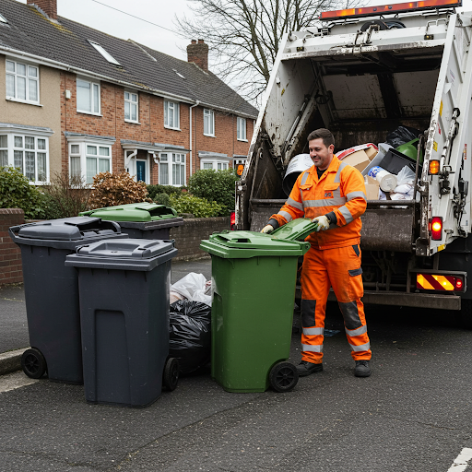

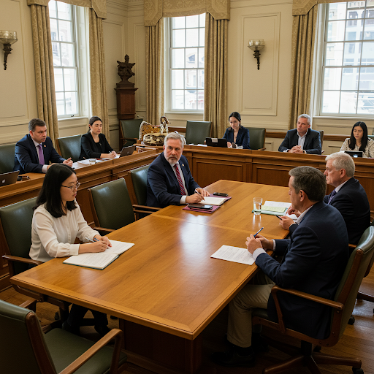
Elected Members:
40 people are chosen by you to represent you on the Council.
They decide how Council money and property is used and how to make our area better.
One Elected member is known as the Mayor, they represent our area.


About 1,000 people work for the Council all with different jobs.
The Chief Executive is the person in charge.
The Leadership Team manage departments, making sure that everything works and making plans.

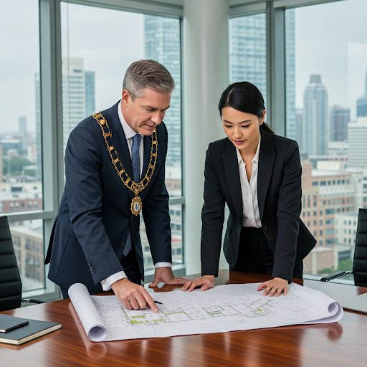
The Mayor and the Chief Executive want the Equality plan to work well.
They will use all the things the Council has to help like money, people and time.

Getting Information in a Way That's Easy for You
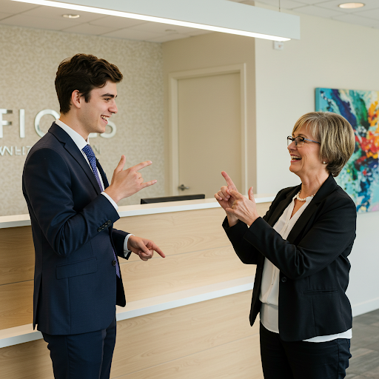

The Council wants to make sure everyone can understand important information. So, they can give you:
- Big letters: If you find small print hard to read.
- Easy words: If you need things explained simply.

- Someone to read it to you: If you want to listen to the information.
- Translated into other languages: If English isn't your first language.
- Use sign language
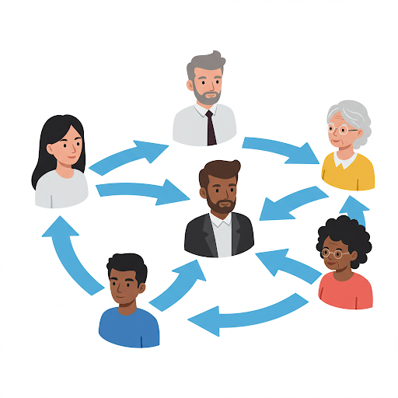
Working Together
We want everyone in our area to be able to tell us what they think. We want to know how we can make our services and plans better.

Sharing the Plan


We will put the plan on our website and social media. If you need extra help to understand, contact the Compliance Officer (Equality and Disability), Telephone: 0300 0133333 or email equality@disability@ardsandnorthdown.gov.uk
Ards and North Down Draft Equality Action Plan 2025 - 2029
This is our plan for 4 years.
Big Goal 1. Help us decide What services we give. What plans we make. Where we spend money.


Helping everyone use computers and smart phones
We want everyone to be able to use our online services.
This is important for older people and people with disabilities.
We will still have phone lines and places people can visit if they don't want to use computers.

We want to make sure everyone can get information from the Council in the language and format they need.

We will use Sign Video more in Council buildings and have more translation services.
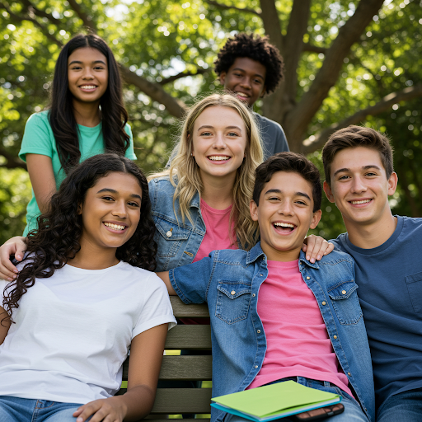

We want more young people to tell us what they think.
Young people will feel welcome and included in what the Council does.
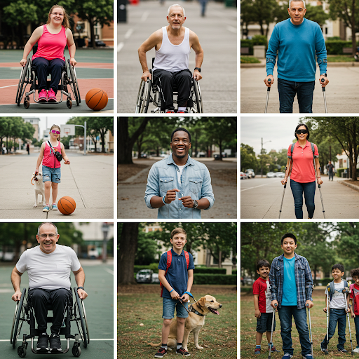
We want to help people with disabilities get the help they need.
Our workers will learn about disabilities. We will take away
things that stop people from using our services.

Big Goal 2. Making our area's money strong
We want to help our area's money grow for everyone can have a good life.


Helping people get jobs
We want to work with businesses to create jobs for people who don't have one.
We will help people find jobs and help businesses find workers.
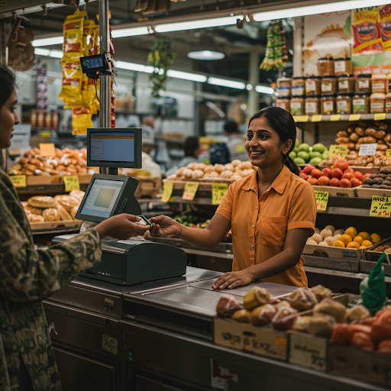
We want to make sure everyone can use our programs that help businesses.
We will help more businesses owned by people who are often left out.

Big Goal 3. Making our area a fun and happy place
We want to make our area a place where everyone feels welcome and happy.

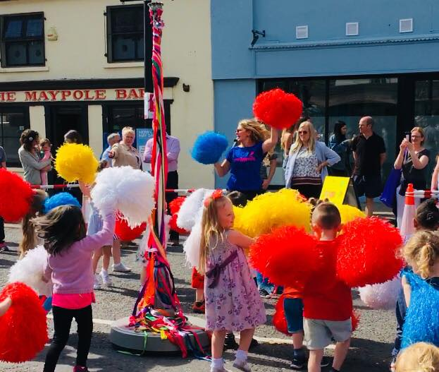

We want to work with community groups to help everyone in our area feel appreciated.
We want our area to be a fun, pretty, and pleasant place for everyone who lives here, visits, or has a business here.

Helping our areas
We will work with groups to help people feel good and help our areas grow.
We finish projects that make our areas better places to live

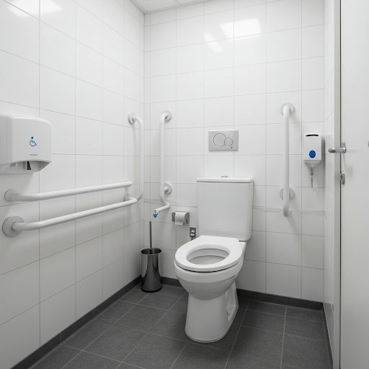
Making parks and beaches easier for families
We want to make sure there are toilets that are easy for families to use in our parks and beaches.
There will be family-friendly toilets in our parks and Beach areas.

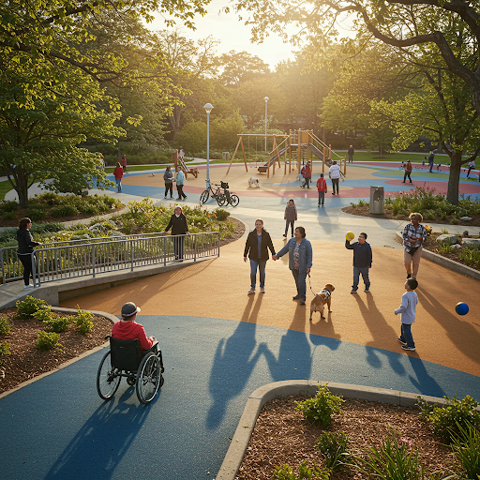
Getting people to enjoy the outdoors
We want more people to have fun in our parks and on our beaches. We will make events that everyone can join in.

More people will be using our outdoor spaces, and more people will join our events.

Big Goal 4. Making our communities safe and friendly

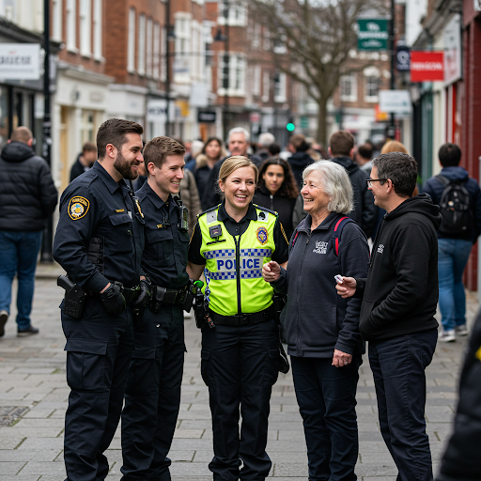

People from different groups to talk to each other and feel included.
We want to help people in our communities work together, especially people from different groups
We will meet the goals in our plans about good relations and communities.

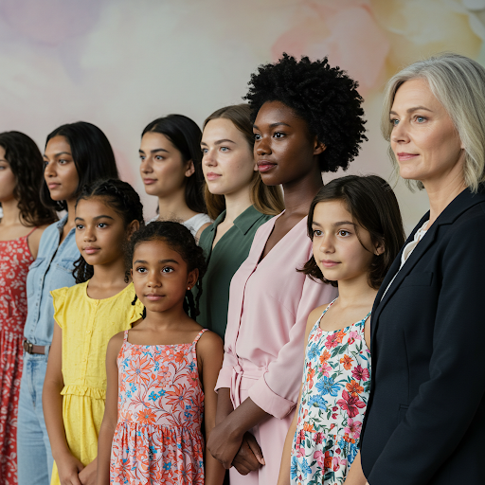
Stopping Violence against Women and Girls
We want to stop all kinds of violence and harm that hurt women and girls. We want to fix the reasons why this happens.


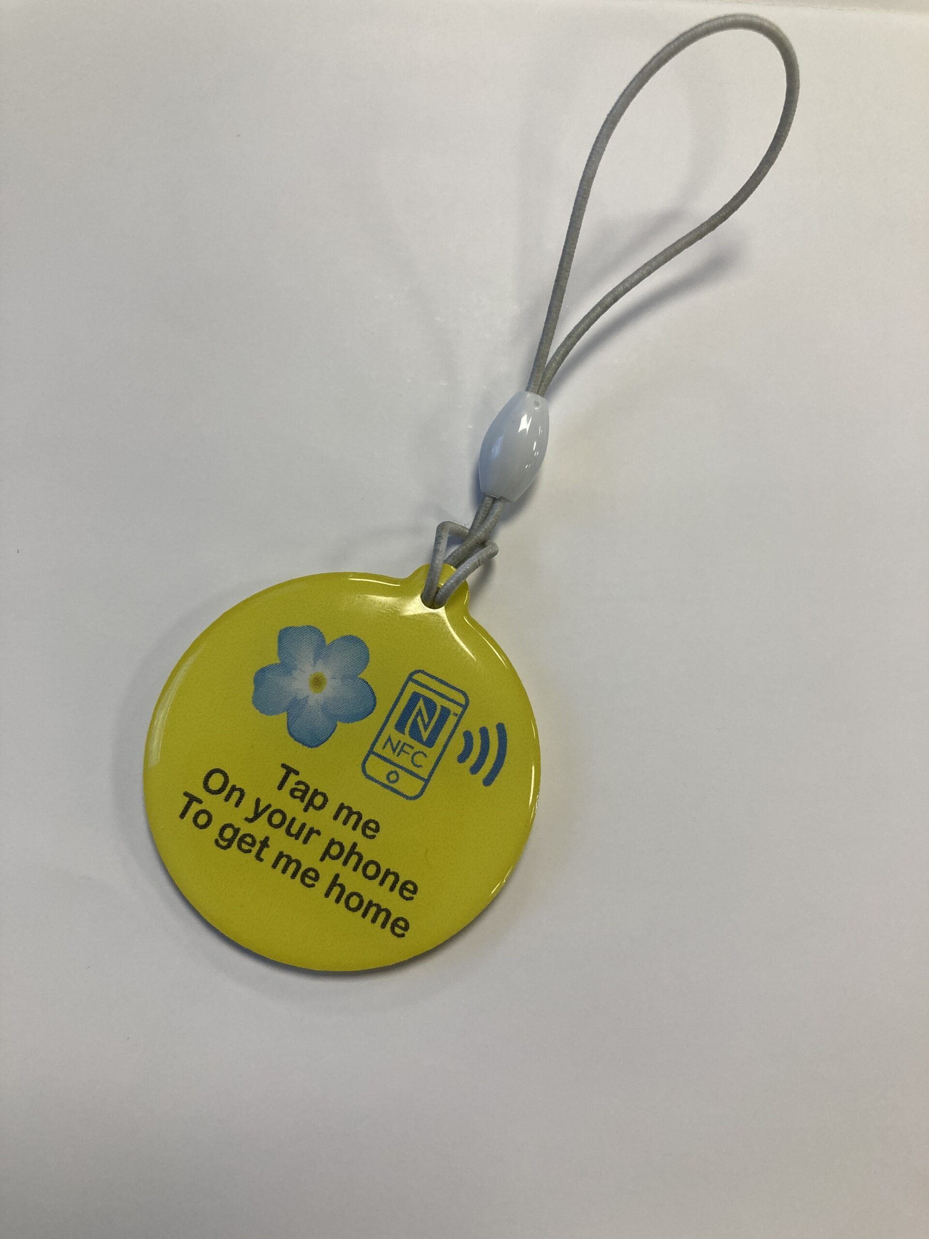
Dementia Safeguarding Scheme
We will provide wristbands and hang - tags that have information so people with dementia can be more independent

Big Goal 5. Helping people be active and healthy
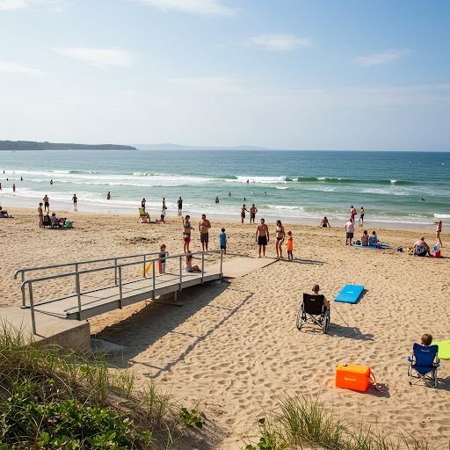

Making Groomsport Beach easy to use
We want to make sure the beach and toilets at Groomsport are easy for everyone to use.
Families and groups will have fun together on the beach.

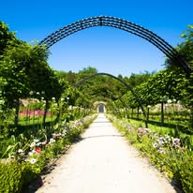
Helping parks
We want groups of friends to help make our parks and green spaces better.
More people will help in their community. Our parks will be looked after better. People's ideas for our parks will be heard and used. People will feel more connected to their community.
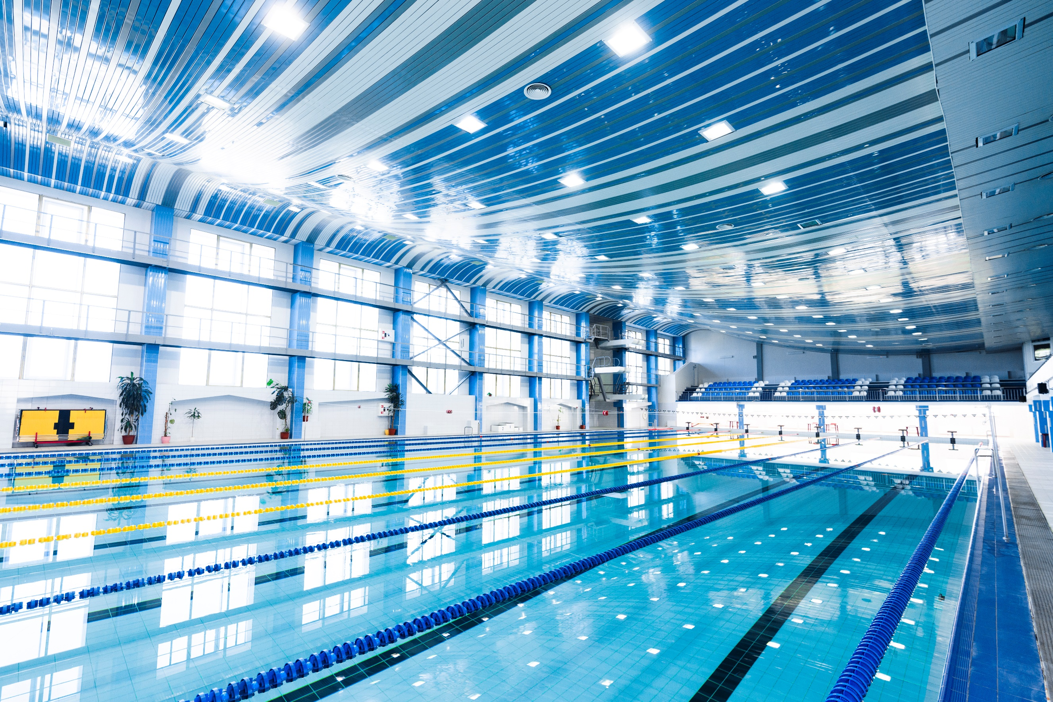

Making Leisure activities open to everyone
We want to take away things that stop people from joining in leisure activities. We want everyone to have fun and meaningful experiences.

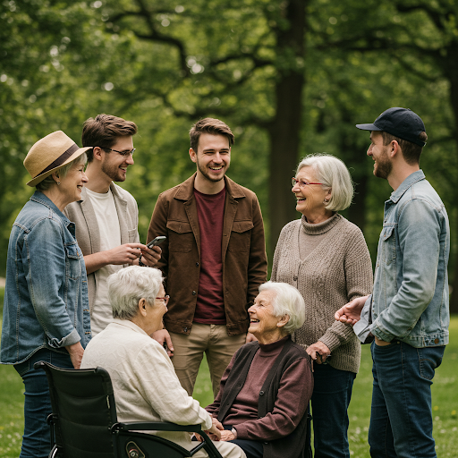
Age Friendly Borough
We will make sure that people of all ages can live a healthy active life

Big Goal 6. Having a Council that works for you

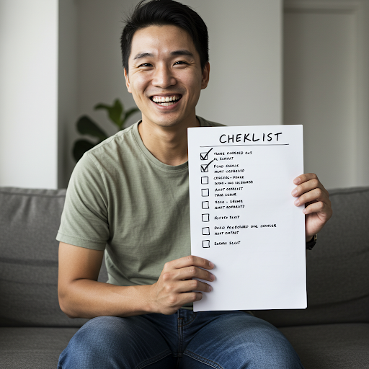
Making sure everyone has a fair chance

We will check all our rules to make sure they are fair and help people get along. We will have meetings every year to check how we are doing inside the Council.

Making our workplace friendly to everyone
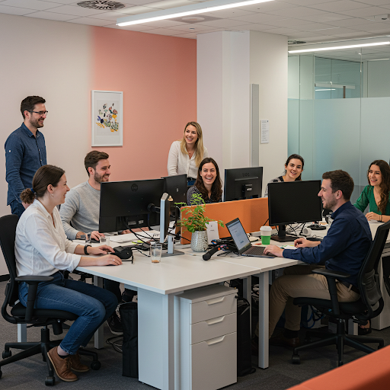

We will listen to and help people from different backgrounds who work for the Council, so everyone feels included.
We will plan to make sure everyone feels welcome, safe, and valued.
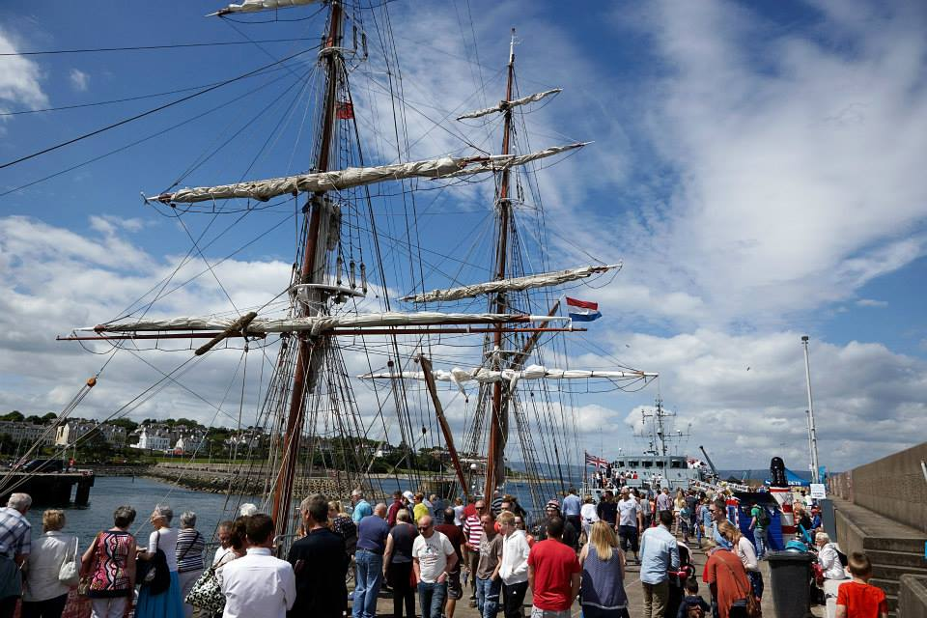

Helping groups that are often left out

We will have special events to help groups that are often left out and to teach people about them.

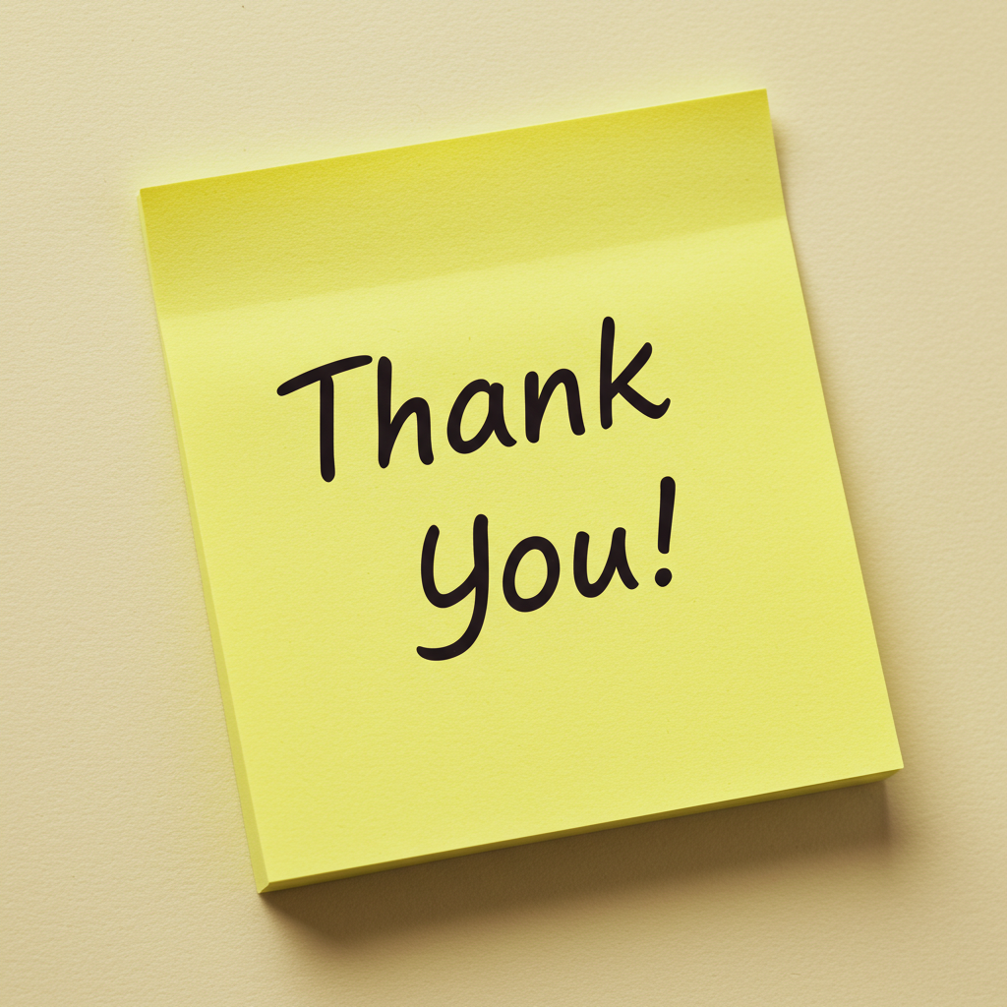
We need you to tell us what you think of our plan.
You can answer these questions on a computer
or smart phone.
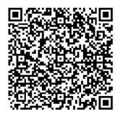
Scan this code with your smart phone
If you want to talk to us, you can phone us too.
Call and ask for the Equality Officer 0300 013 3333 or email equalityanddisability@Ardsandnorthdown.gov.uk
Thank you

