Youth Shelters – extract from Tender

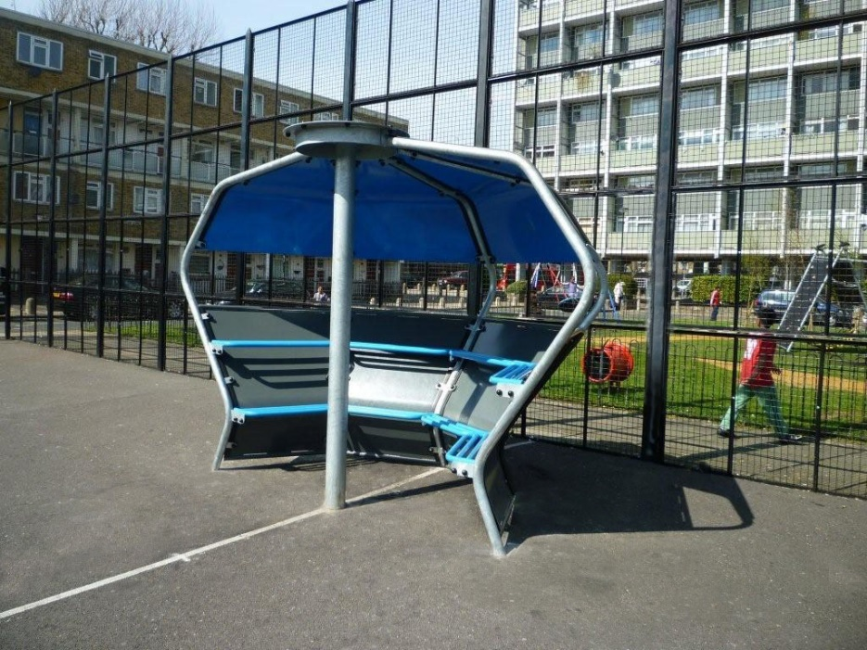
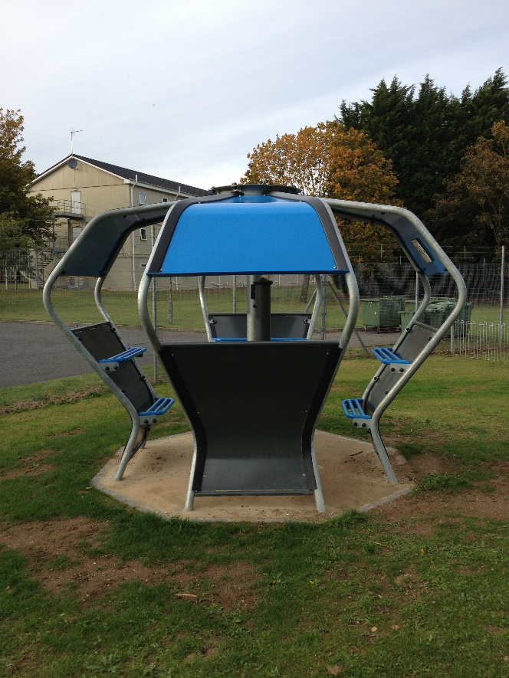
Any of the 7no. side panels can be removed when needed to create a more open Pod as below

The shelters must be modular to allow for different but appropriate configurations to be installed at each site. However, these adjustments will be agreed with the successful supplier following contract award. Any adjustments must remain within the overall budget for this project.

For evaluation purposes, the tenderer must base their submission for a shelter with one opening for entrance/exit. However, Council will agree with the successful tenderer, the most suitable configuration for each of the sites.

All welded joints and machined areas are dressed free of burrs and sharp edges. Posts are then hot dip galvanized to give total corrosion resistance both inside and out.

