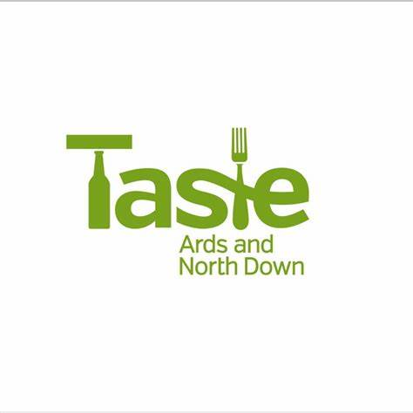
Tastes and Tales of Comber
The Comber Earlies Festival Tour with Lolly Spence

Appetiser
Comber Earlies Potato and Pear Soup with Crispy Bacon
Mains
Local Irish Moiled Beef, Hugh Maguire’s Smoked Black Pudding Galette, Oxtail, Smoked Garlic, and Confit Onion
Dessert
Strawberry Tartlet with Cream and Locally Grown Strawberries, Quenelle of Glastry Farm Vanilla Bean Ice Cream, Homemade Shortbread and Strawberry Gel
Cheese Course
Indie Fude Cheese Board with a glass of Mc’Bride’s very own Craft of Draft IPA

Timings

12:00 - Meet Lolly and enjoy appetiser at McBride’ on the Square 25 minutes)
12.25 – Tour Part 1 - to cover origins of Comber, Bridge Street, Cherryvalley, Distillery (45 Minutes)
1.10 - main course at No.14 Restaurant (50 minutes)
2.00 – Tour Part 2: to cover High Street, the Railway, the Andrews Mill, Andrews Hall Castle Street (45 Minutes
2.45 - Dessert and coffee at Sugarcane Café Bistro (30 minutes)
3.15 – Tour Part 3: go walking - to cover the square area including St Mary's, Rollo, Wars
3.45 - Cheese & Beer at McBride’s on the Square.

